MONDAY 1  Canada Day Closed  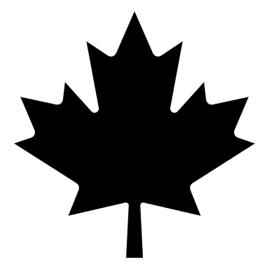 | TUESDAY 2   | WEDNESDAY 3  Britannia Mine Museum  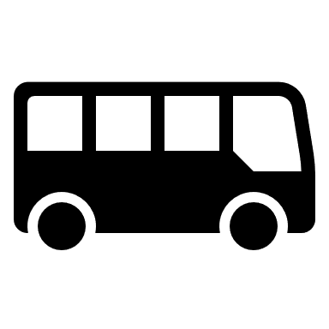 | THURSDAY 4  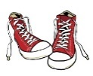 | FRIDAY 5  Playland
MONDAY 8  Pirate Adventures @ Granville Island | TUESDAY 9  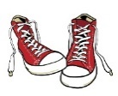  Magician | WEDNESDAY 10  Stanley Park | THURSDAY 11  Beach Day | FRIDAY 12  PIZZA DAY
MONDAY 15  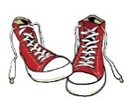  Bouncy Castle | TUESDAY 16  Splash Water  Park Tsawwassen | WEDNESDAY 17 | THURSDAY 18  Jericho Beach | FRIDAY 19  
MONDAY 22  Cates Park | TUESDAY 23 | WEDNESDAY 24 | THURSDAY 25  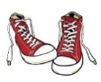  Candy Workshop | FRIDAY 26  Science World
MONDAY 29  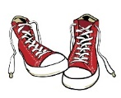  Art workshop | TUESDAY 30  Grouse Mountain | WEDNESDAY 31 | THURSDAY 1  Mahon Water Park | FRIDAY 2  Pizza day!
MONDAY 5  CLOSED BC DAY | TUESDAY 6  Candy Workshop  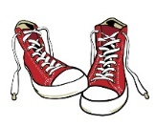 | WEDNESDAY 7  6 Pack Beach | THURSDAY 8 | FRIDAY 9  PJ KIDS CLUB 43rd BIRTHDAY  Bouncy Castle Fun
MONDAY 12 | TUESDAY 13  Sea To Sky Gondola | WEDNESDAY 14  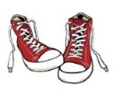 | THURSDAY 15  Whitecliff | FRIDAY 16  Pizza day!  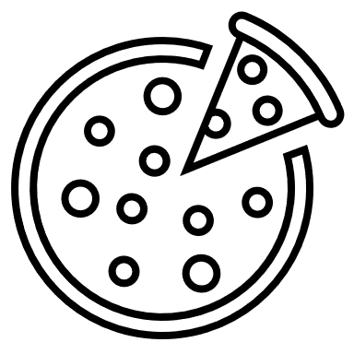
MONDAY 19  Vancouver Aquarium | TUESDAY 20  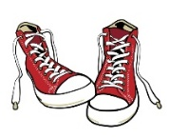 | WEDNESDAY 21  Jerico Beach | THURSDAY 22 | FRIDAY 23  PIZZA DAY
MONDAY 26 | TUESDAY 27  Bowen Island | WEDNESDAY 28  Norden The Magician   | THURSDAY 29  Bowling | FRIDAY 30  

